**WORKING WITH GIT REPO**

STEP 1:

CREATE A GITHUB ACCOUNT AND LOGIN TO GITHUB

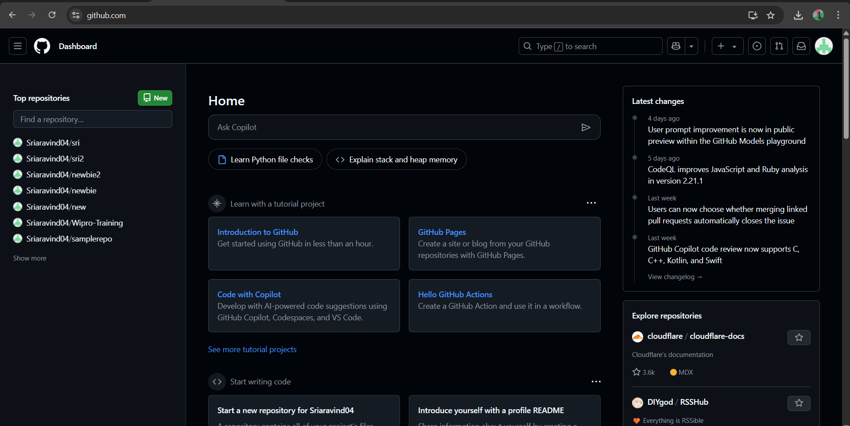

STEP 2:

CREATE A NEW RESPOSITORY

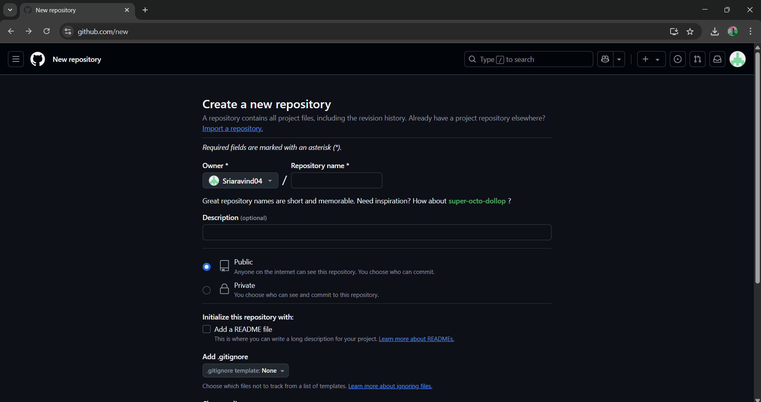

STEP 3: COPY THE URL

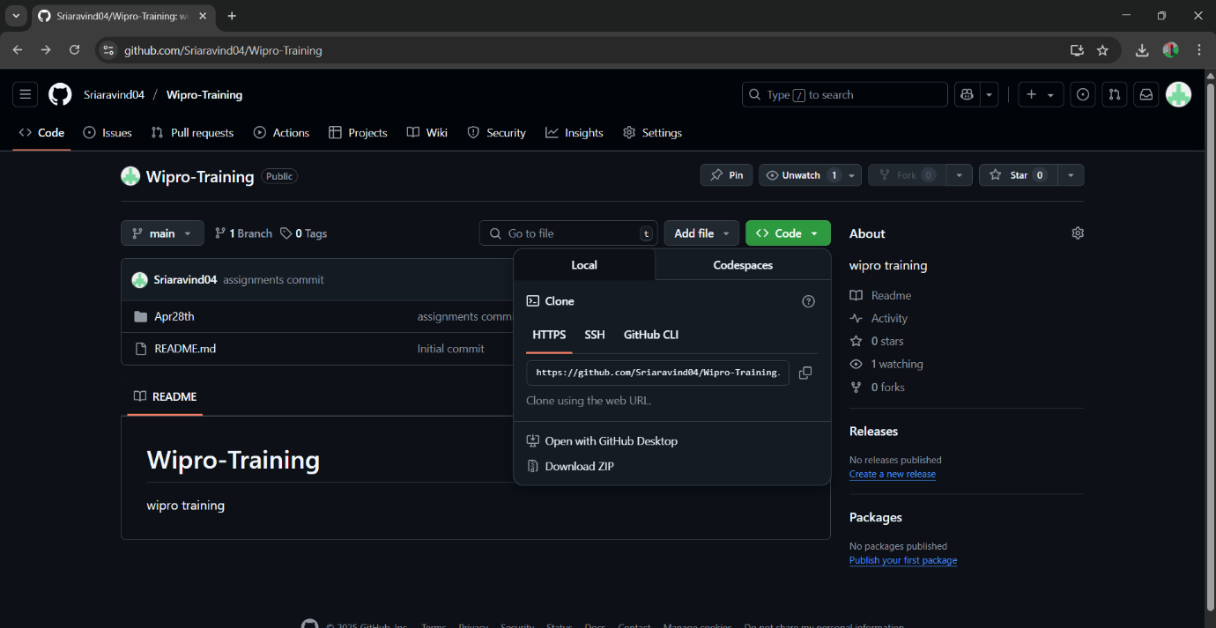

STEP 4:

DOWNLOAD VISUAL STUDIO CODE,GIT AND LOGIN

STEP 5:

CREATE A NEW FOLDER AND CLONE THE GIT

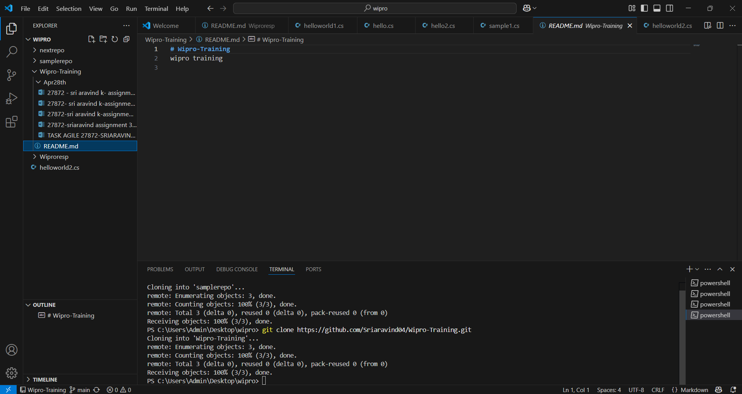

STEP 6:

AFTER CHANGES COMMIT AND PUSH

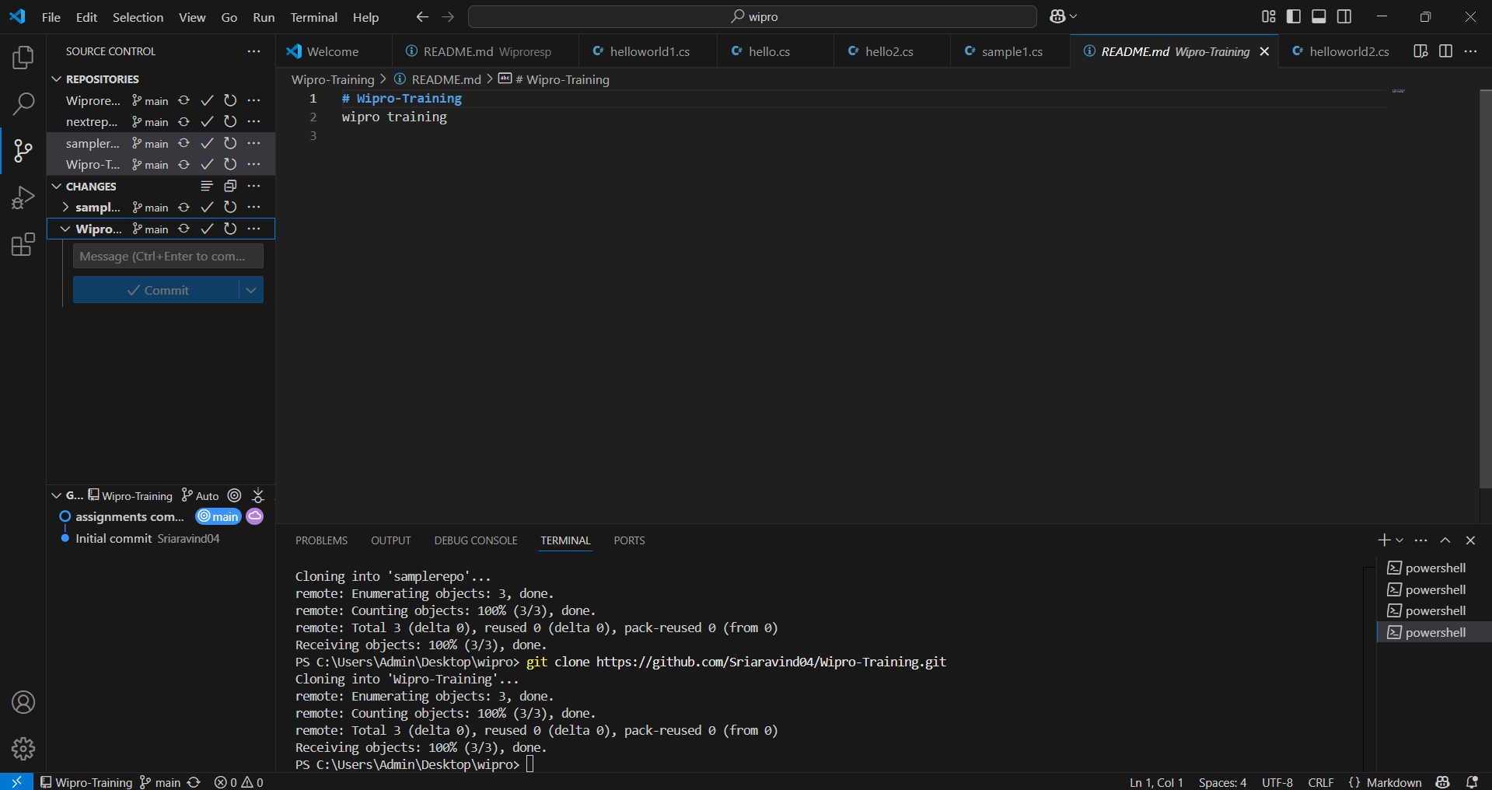

STEP 7:

FILES ARE UPLOADED IN GIT RESPOSITORY

